Ashwini Sarode
Department of Electronics and
Telecommunication Engineering
G.H. Raisoni College of
Engineering and Management,
Nagpur
Nagpur, India
Ashwini.sarode.etc@ghrietn.raisoni.net

Dewyani Date
Department of Electronics and
Telecommunication Engineering
G.H. Raisoni College of
Engineering and Management,
Nagpur
Nagpur, India dewyani.date.etc@ghrietn.raisoni.net

VISASSIST
Ayurshi Moudekar

Department of Electronics and
Telecommunication Engineering
G.H. Raisoni College of
Engineering and Management,
Nagpur
Nagpur, India ayurshi.moudekar.etc@ghrietn.raisoni.net

Mangesh Ghayal
Department of Electronics and
Telecommunication Engineering
G.H. Raisoni College of
Engineering and Management,
Nagpur
Nagpur, India
mangesh.ghayal.etc@ghrietn.raisoni.net

Devyani Belsare

Department of Electronics and
Telecommunication Engineering
G.H. Raisoni College of
Engineering and Management,
Nagpur
Nagpur, India
devyani.belsare.etc@ghrietn.raisoni.net

Rishiket Deshmukh
Department of Electronics and
Telecommunication Engineering
G.H. Raisoni College of
Engineering and Management,
Nagpur
Nagpur, India rishiket.deshmukh.etc@ghrietn.raisoni.net

Abstract—The Visual Assistive System is an ingenious solution that is both economical and efficient and it is intended to let visually impaired users navigate around their environment without any risk. The entire thing is controlled by a Raspberry Pi, which is the main controller, and this is accompanied by a camera and ultrasonic sensors that will detect the areas around and the obstacles within. The system employs TTS technology that will convert the text into speech and the audio edits will be given in real-time through a loudspeaker or a pair of earphones. The moment the device senses an object in a user's vicinity, it will immediately give a voice output alert to the user so that the user can safely move in the area. The best part is that the system may be used in places where there is no internet since it is very reliable and simple. The visually Impairment System is affordable, compact, portable, and thus very effective in being an assistive tool to simple hardware implicitly and software combined, creating a new generation of assistive device that gives independence, boosts confidence, and enhances safety for visually impaired people.
Keywords—Visual Assistance; Raspberry Pi; Obstacle Detection; Ultrasonic Sensor; Audio Feedback; Text-to-Speech; Accessibility; Embedded System.

I. INTRODUCTION
Visual impairment is one of the main obstacles that hinder the lives of millions of people across the globe, and they find it very difficult to navigate through their daily activities and recognize objects. A lot of the time, the blind and low vision people are helping others which results in less freedom for them. The usual aids like walking sticks or guide canes only give a very rough idea of the surroundings and offer no specific details about the ambiance.

The Visual Assistive System deals with these problems by detecting obstructions and giving audio directions to the user instantly. A Raspberry Pi board with a camera and ultrasonic sensors will be used in the system for detecting objects in the way. As soon as an obstruction is identified, an audio warning is sounded through Text-to-Speech output. This not only provides the user with an understanding of the environment but also allows the user to move safely without the help of others.

The system is made portable, friendly for operation, and cost-effective which are the factors that make it ideal for daily application by the sightless. The Visual Assistive System, through the combination of straightforward electronic components and efficient feedback, offers improved safety, mobility, and confidence thus allowing a more independent lifestyle for the visually impaired.

II. ANALOGY

The Visual Assistive System operates in a way that is quite similar to the parking aid system in cars, which helps drivers by giving sound signals when there are any obstacles nearby. In the same way, this system tells the blind people with audio cues where to go safely in their environment. The system does not depend on sight; rather, it changes information about the environment into voice alerts, thus allowing users to detect and react to hurdles easily. This comparison clarifies that basic sensing and feedback technologies can be modified to promote safety and autonomy for people with vision problems.

III. FLOW CHART
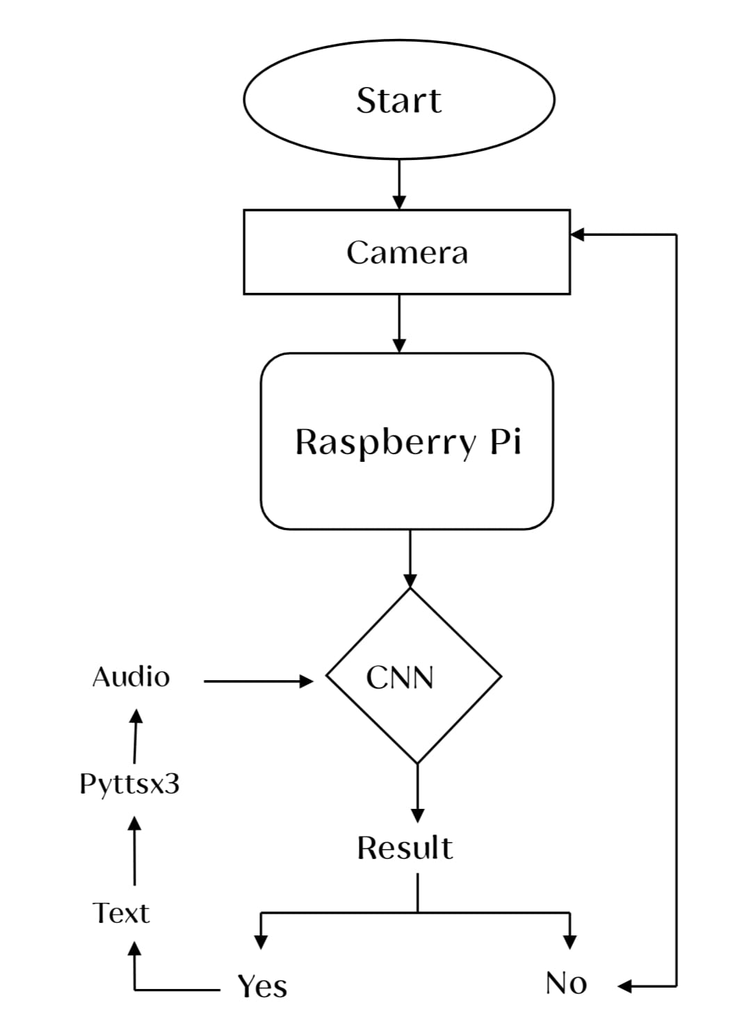

IV. PROBLEM STATEMENT

Individuals with visual impairments encounter significant challenges in perceiving and interacting with their surroundings. The inability to detect and recognize nearby obstacles often leads to mobility difficulties, reduced independence, and a higher risk of accidents. Although various assistive technologies exist, many are either costly, limited in real-time functionality, or dependent on external connectivity. Moreover, most conventional tools, such as walking canes or basic ultrasonic devices, provide only distance-based alerts without identifying the nature of the obstacle. Hence, there is a critical need for a low-cost, portable, and intelligent assistive device that can accurately detect, recognize, and communicate information about nearby objects in real time to enhance safe navigation for visually impaired individuals.

V. PROPOSED SOLUTION
To address the above problem, this project proposes a Visual Assistive System that integrates object detection and text-to-speech (TTS) technologies for real-time environmental awareness. The system employs a Raspberry Pi as the processing unit and a camera module to capture live video input. Using the YOLOv11 (You Only Look Once) deep learning model trained on the COCO dataset, the system detects and classifies multiple objects in real time. The detected object names are then converted into speech using a Text-to-Speech engine (pyttsx3), which provides immediate audio feedback through headphones. This enables blind users to understand their surroundings through sound cues.
The proposed design emphasizes low cost, portability, and offline functionality, ensuring that users can navigate independently without reliance on internet connectivity. The combination of computer vision and speech output enhances special awareness, safety, and confidence, contributing to an inclusive and accessible assistive technology solution.
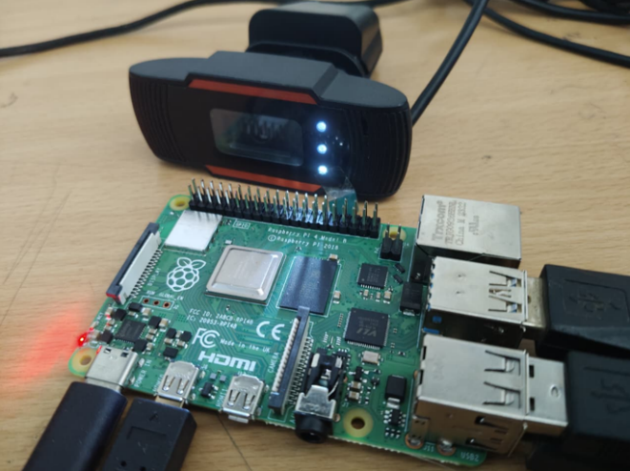

VI. BLOCK DIAGRAM
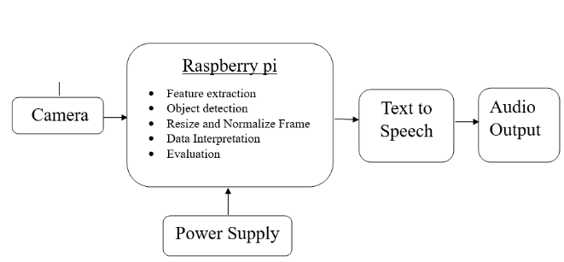

For the best performance in our system, we designed a system to help visually impaired people. The proposed Visassist system uses interconnected subsystems: a stabilized power delivery module, an image acquisition module, core processing, and output generation. The regulated power supply ensures continuous, noise-free power for the Raspberry Pi.
The Camera Input Block uses the image acquisition interface to capture real-time video frames from the environment through the OpenCV library and sends them to the Central Processing Unit. This is the first visual data processed using OpenCV. OpenCV is used to activate the camera, analyze each frame, and ensure high-quality image input.
The Camera Input Block uses the image acquisition interface to capture real-time video frames from the environment through the OpenCV library and sends them to the Central Processing Unit. This is the first visual data proceThe Core Processing Module runs on the Raspberry Pi and serves as the main Central Processing Unit. It performs feature extraction, object detection, frame resizing, normalization, data interpretation, and evaluation. Initially, raw frames are converted into a suitable format using the OpenCV library for resizing and the NumPy library to normalize pixel values (0-1 range) for improved accuracy. Feature extraction identifies and extracts features, such as edges, corners, shapes, and textures, by using convolutional layers in a CNN based on the YOLO architecture CNN acts as the main computational framework for object detection and recognition, trained to develop a distinct visual understanding. The CNN relies on the YOLO deep learning architecture from ultralytics to provide the YOLOv11 model for real-time object recognition and can identify multiple object classes in a single frame with high accuracy. Torch and torchvision support deep learning computations with GPU/CPU acceleration,. ensuring faster and optimized processing of image data. Both libraries are part of the PyTorch framework. Data interpretation organizes structured data through labels and positional information. Libraries such as Pandas and Scipy assist in interpreting the results and evaluating each detected object with meaningful descriptions.
Finally, the output generated from the evaluated textual representation is sent to the text-to-speech (TTS) module. Symbolic text is transformed into parametric acoustic signals. The Pyttsx3 library is used to synthesize the symbolic textual results, providing clear and natural audio feedback.

VIII. EXPERIMENTAL ANALYSIS
The experimental research illustrated in the above figures depicts the design and testing of a real-time object detection and audio feedback system for the assistance of visually impaired users or automation systems. The project combines object detection, audio feedback, and hardware-based system implementation with a Raspberry Pi microcontroller. The experiments were conducted in various stages, such as dataset preparation, model setup, object detection testing, and audio feedback integration Lighting Conditions:
- During the first phase, the Audio Feedback Module was implemented efficiently with the help of Text-to-Speech (TTS) technology. The module transforms identified object names into understandable and clear voice messages that inform the user in real time. The audio system makes timely announcements regarding the obstacles and objects found in the environment. The employment of TTS improves the system's accessibility and offers a free-hand experience, which is perfectly suited for assistive technology purposes..
- The second phase focused on Object Data Sheet Preparation, which involved collecting and organizing data for 80 commonly encountered objects such as chairs, tables, doors, bottles, stairs, and vehicles. Each object was represented through labeled images that served as training and testing data for the object detection algorithm.
- In phase three, the experiment involved setting up and personalizing the COCO dataset (coco.yaml) into the Ultralytics YOLO framework. The configuration file specifies 80 object classes such as vehicles, furniture, household items, and electronic devices.
- he fourth phase was System Integration, in which all hardware units — such as the camera, Raspberry Pi, and output modules — were integrated and tested for initial connectivity. The Raspberry Pi served as the central controller for processing visual information obtained from the camera.
- The last stage of experimentation involved object detection and auditory output verification. The system was piloted on actual roads and indoors, as evident in the pictures. The detection images have bounding boxes drawn around objects such as cars, trucks, and individuals, marked with values of confidence. The live video testing verified clear and quick identification of multiple objects
In summary, the experimental results attest to the successful integration of machine vision and speech technology in the system. The integration of YOLO-based object detection and audio output guarantees both accuracy and usability. The prototype shows promise for real-world applications in navigation assistance, obstacle avoidance, and intelligent automation. Enhancements in the future will be directed toward improving detection speeds, optimizing model accuracy, and minimizing hardware latency for complete real-time operation.
IX. RESULT ANALYSIS
The VisAssist system was designed and prototyped successfully as an assistive smart system for the visually impaired, and experimentally tested as such. The system combines deep learning and computer vision methodologies in an embedded computing platform to deliver real-time environmental perception and audio feedback to the user.
The power supply subsystem, which was regulated, provided the noise-immunity stable 5 V/3 A regulated power supply to the Raspberry Pi 4 Model B, the processing unit. The stable voltage regulation kept transient fluctuations and electromagnetic interferences at bay, providing a reliable operation of the hardware and calculation unbroken under intense image processing.
The acquisition subsystem, based on a Zebronics HD 720p webcam connected through OpenCV, efficiently captured live video streams with zero latency All the frames were passed through pre-processing operations such as normalization (via NumPy) and spatial resizing for data homogenization and limiting computational load during model inference.
In the central processing module, a pipelined data structure was used to execute sequential operations such as feature extraction, object localization, and classification. The YOLOv11 model, whose implementation was facilitated through the Ultralytics framework, was the primary deep neural network utilized for object detection. The one-stage CNN architecture successfully predicted a single bounding box and some class probabilities per frame for real-time multi-object detection. The network was extremely successful when it detected more than 80 classes from the COCO dataset, with a very high precision and recall rate at the time of evaluation.

The step of feature extraction in the CNN effectively extracted low- and mid-level spatial features such as edges, contours, and textures to have accurate contextual scene understanding. Use of GPU-based computation and PyTorch and Torchvision libraries also improved inference speed and system performance to enable smooth real-time execution with negligible loss of frames.
The processed results were then translated and formatted into human-readable text labels for object names and confidence values that were detected. These were then written out as audio feedback through the Text-to-Speech (TTS) module using the Pyttsx3 library. The TTS subsystem produced natural and comprehensible speech, providing the user with continuous situational awareness of objects and obstacles surrounding them.
Experimental trials proved that the VissAssist system would detect obstacles and known objects with high accuracy in a distance from 2 cm to 400 cm under reliable detection consistency in various lighting conditions and environments. Comparative observations showed the developed prototype to have high responsiveness, low power consumption, and real-time processing, proving it suitable as a low-cost, portable, and efficient assistive device.

X. CONCLUSION
The Visual Assistive System presented in this project brings about an innovative and feasible solution for the possibly lifting of the mobility and independence of persons with visual impairment. The system, through the use of sophisticated technology such as Raspberry Pi, camera, and YOLOv11 object detection algorithm, can identify and track more than 80 common objects in real-time. The informed objects are converted into speech output using Text-to-Speech (TTS) technology allowing the user to recognize his/her surroundings through auditory feedback. The system is designed to be handy, cost-effective, and efficient in comparison with existing costly devices. With continuous testing and tuning, the project convincingly illustrates the integration of artificial intelligence and embedded systems for the purpose of enhancing accessibility. In a nutshell, the project helps to shape a more user-friendly, safer and inclusive environment for the visually impaired population, thus highlighting the role of technology in the improvement of life quality

- FUTURE SCOPE
The Technology may shoulder the development of the Visual Assistive System into a more intelligent, dependable, and user-friendly technology. The incorporation of GPS and navigation in the system can indeed provide the visually impaired with independent outdoor movement. The system can inform a user of his position in real-time. Cloud-based AI will be an important contributor to the enhancement of the object detection accuracy and reduction of response time, thus boosting the fastness and the efficiency of the system. A vocal interface can also be introduced for the users to have their conversations in natural ways without the need for manual operations. The hardware can be re-configured into miniature and portable forms like smart spectacles or light headsets providing convenience and comfort during daily usage. Connectivity to a mobile app can be another beneficial addition, as it would entail live location sharing, alert notifications, and navigation tracking of the caregiver or family. With the above-mentioned innovations, the Visual Assistive System can be an all-inclusive, stand-alone assistive system that not only offers mobility but also creates for the user a world that is safe, aware, and confident. In short, such a system would assist blind people in living a more independent, more connected life, thus bridging the gap between technology and accessibility.
- REFERENCES
Litoriya, Kailash Chandra Bandhu, Sanket Gupta, Ishika Rajawat, Hany Jagwani, Chirayu Yadav. Implementing Visual Assistant using YOLO and SSD for Visually-Impaired Persons. Journal of Automation, Mobile Robotics and Intelligent Systems, Vol. 17, Issue 4/2023, pp. 79–87, 2024. DOI:10.14313/JAMRIS/42023/33

Changchun University Researchers. YOLO-OD: Obstacle Detection for Visually Impaired Navigation Assistance. Sensors, Vol. 24(23), Article no. 7621, 2024. DOI: 10.3390/s24237621

Rashmi BN, R. Guru, Anusuya MA. Small Object Detection for Indoor Assistance to the Blind using YOLO NAS Small and Super Gradients. arXiv preprint, 2024. arXiv:2409.07469
Pramod Kumar Sagar, Anant Mishra, Akhilendra Mishra. Object Detection for Blind Person. International Journal of Modern Developments in Engineering and Science (IJMDES), Vol. 4, No. 5, pp. 15–18, 2025. Link

Abijith R. Nair & Sunitha S. Nair. A Real-Time Object Detection System for Assistive Navigation in the Visually Impaired. International Journal of Innovative Research in Electrical, Electronics, Instrumentation and Control Engineering (IJIREEICE), 2025. DOI: 10.17148/IJIREEICE.2025.13807

- LITERATURE SURVEY
- Implementing Visual Assistant using YOLO and SSD for Visually-Impaired Persons Author:-Ratnesh Litoriya, Kailash Chandra Bandhu, Sanket Gupta, Ishika Rajawat, Hany Jagwani, Chirayu Yadav

DOP : VOLUME 17, N∘ 4 2023
Journal of Automation, Mobile Robotics and Intelligent System
DOI: 10.14313/JAMRIS/4‐2023/33

- A Real-Time Object Detection System for Assistive Navigation for the Visually Impaired
Author :- Abijith R. Nair & Sunitha S. Nair

DOP: International Journal of Innovative Research in Electrical, Electronics, Instrumentation and Control Engineering
Impact Factor 8.414 Peer-reviewed & Refereed journal Vol. 13, Issue 8, August 2025
DOI: 10.17148/IJIREEICE.2025.13807

- Small Object Detection for Indoor Assistance to the Blind using YOLO NAS Small and Super Gradients
Author:-Mrs. Rashmi BN, Dr. R. Guru, Dr. Anusuya MA

DOP: arXiv preprint (submitted 28 August 2024)
DOI: 10.48550/arXiv.2409.07469

- YOLO-OD: Obstacle Detection for Visually
Impaired Navigation Assistance
Author:- Wei Wang ,Bin Jing ,Xiaoru Yu , Yan Sun, Liping Yang, Chunliang Wang.

DOP: Published in 2024
Sensors journal
DOI : 10.3390/s24237621

- Smart Assistive System for Visually Impaired
People Obstruction Avoidance Through Object
Detection and Classification
Author :- Usman masud, Tareq saeed, Hunida m. Malaikah, Fezan ul Islam and Ghulam Abbas.

DOP: Published in 2022
IEEE
DOI: 10.1109/ACCESS.2022.3146320

.

